Portfolio Projects

# Humanoid Robot

<icon image from Misbah bhai>

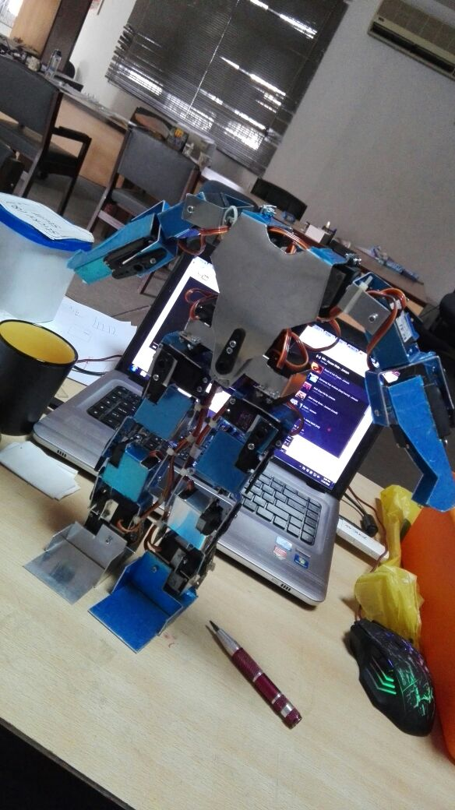

This humanoid robot is the effort of me and one of my friend Misbah-ur-Rehman. It was presented as his academic project. The robot is actually a shadow robot that moves like a human being moves. At this stage the robot is capable of mimicking the arms and shoulders.

To capture the angles and the motion of a human body, Xbox Kinect is installed at some distance. An application then captures and calculates the angles on the human body frame captured by Kinect. After some processing on the angles it then transmits these angles to the robot where 19 servo motors follow the same angles and follow the same posture as posed by the human.

See video below:

Angles capturing: